Cavitation Induction by Projectile Impacting on a Water Jet
¹E. Stavropoulos Vasilakis*; ¹P. Koukouvinis; ²M. Farhat; ¹M. Gavaises;
¹School of Mathematics, Computer Science and Engineering, CITY, University of London, UK;
²Laboratory of Hydraulic Machines, EPFL, CH
Abstract
Following the work of Field et al. [4], who experimentally visualised cavity formation and shock propagation in impacted liquids at high velocities, the present study focuses on the simulation of the high velocity impact of a solid projectile on a water jet. The undeformable solid projectile is modelled through a direct forcing Immersed Boundary Method. The simulation is carried out using an explicit density based compressible solver, developed by Kyriazis et al. [6], which employs a two-phase flow model and includes phase change. This study gives a better insight on the phenomena following the impact of solids on liquids, including shock propagation and vapour formation, and demonstrates the capabilities of the presented Immersed Boundary Method to handle compressible cavitating flows.
Keywords: Immersed Boundary Method; Cavitation; liquid solid impact
Introduction
High velocity liquid impacts on solids consist a broaden category of physical problems of high interest, as they take place in many engineering applications and affect drastically the performance of machines operating in high velocities and under high pressures, as they are linked to cavitation formation and erosion development and eventual damage of the solid surfaces. Such applications may refer to erosion induced in hydraulic machines [4] or by rain drops on airplanes and wind turbine blades [1]. Field [3] [4] along with Lesser [7] and Bowden and Brunton [2], have conducted many theoretical and experimental studies on the mechanisms of liquid impacts on solids or liquids, and have established a solid understanding of the phenomena taking place in such cases.
Field et al. in their recent paper [4], summarise the experiments conducted on liquid to liquid and liquid to solid impacts, focusing on the complicated shock structures and the high-speed jetting on the area of impact. According to experimental data, that are in accordance with the theoretical work of Lesser, when a liquid impacts a solid surface, compressibility effects take place near the impact area that lead to high velocity jetting along the solid surface and pressure shock waves are generated that get detached and travel away from contact region. When these waves interact with the free surface of the liquid, during detachment or reflection, systems of relief waves are formed that produce enough tensile stress to initiate cavitation.
The current study focuses on the simulation of a high velocity impact of a solid projectile on a water jet following the experiments of Field et al. [4], in order to investigate the shock structures and the cavitation induction. This simulation poses a significant challenge regarding the modelling of the solid projectile motion. To tackle this issue, an Immersed Boundary (IB) Method is used to model the movement of a solid boundary over the fixed grid of the domain, avoiding any complexities arising from re-meshing or moving meshing techniques. The IB methods, first introduced by Peskin [11] model internal boundaries by either changing the computational stencil near the solid or adding source terms in the equations. The later approach is used in this study, where forcing source terms are added in the momentum equations of an explicit density based in-house solver, developed by Kyriazis [6] on OpenFOAM platform. This solver is able to simulate cavitating flows, where the local Mach number has a wide range, in addition to the advection of immiscible compressible gas. The case of the projectile impact on a water jet serves as an interesting and challenging demonstration of the capabilities of the developed numerical tools.
Numerical Method
The Immersed Boundary (IB) method used in this study, falls in the category of direct forcing methods [8], where the presence of the boundary is taken into account as solid forcing by introducing a source term in the momentum equation. Similar method has been used by Mochel et at. [9] in high velocity compressible turbulent flows as well as by Koukouvins et al. [5] to simulate the cavitating flow resulting from the high-speed closure of the claw of the pistol shrimp. To the best of the authors’ knowledge, apart from the method developed by Koukouvinis, the only IB methodology applied on cavitating flows, such as Diesel injector flows with closing needle, is presented by Orley et al. [10], which consists of a cut cell methodology. The IB method used in the presented study provides important advantages regarding geometrical and topological manipulations, compared to cut-cell methods, and thus results in less time-consuming computations.
The immersed solid boundary is represented by a surface mesh while a mask is used for the computational grid cells enclosed by this surface. This mask representing the solid area, corresponds to the solid volume fraction of the cells and is calculated as the ratio of the cell volume covered by the IB surface over the total cell volume. This calculation is carried out as the average of normal distance between all the vertices of the cell and the nearest IB surface face.
The forcing source term is calculated as the difference of the fluid velocity from the IB solid velocity, and therefore tends to impose no-slip condition on the IB cells. The source term is then multiplied with the IB mask to localise the IB forcing, as in Equation 1.
$${\vec{f}}_{IB}= α_{IBMask}⋅\frac{∆U}{∆t}= α_{IBMask}⋅\frac{U_{fluid}-U_{IB}}{∆t} ,α_{IBMask}∈[0,1]$$
Equation 1 Immersed Boundary forcing term.
The IB forcing term is introduced in the compressible Navier-Stokes equations that are solved using a density based, two-phase, explicit solver, developed by Kyriazis et al. [6]. This solver is based on the homogeneous mixture approach to account for liquid, liquid-vapour and gaseous phases, that are in mechanical and thermodynamic equilibrium. Phase change is considered between liquid and vapour phases, using the linear barotropic law to compute the mixture density. A transport equation is solved for the advection of the gas, considering the gas mass fraction, which is modelled as isothermal ideal gas.
The solver is making use of a special hybrid flux calculation, to tackle issues arising when density based solvers are used for three phase cases with great variations of speed of sound. The hybrid flux is based on Primitive Variable Riemann Solver and Mach consistent flux [6]. The reader is referred to [6] where Kyriazis et al. present the solver in detail.
Results
The current study examines the impact of a projectile, with a diameter of 9mm, at horizontal speed of 210m/s, on a water jet, of 25mm in diameter, which flows vertically with a velocity around 1m/s. The ambient air is initially stationary. The Mach number with respect of the surrounding air is 0.6 and with respect to the impacted water 0.14. The pressure of the domain is considered equal to 1bar and the reference temperature set to 300K. As the projectile velocity is relatively high, turbulence modelling was not used as the boundary layers are expected to be very thin and therefore their influence could be neglected. The domain is discretized by a cylindrical mesh with 128 cells along the diameter of the water jet.
When the projectile impacts on the circular water surface, a peak in pressure is observed and a shock envelop is formed (as seen in Figure 1a) that while the projectile penetrates the free surface gets detached from the solid front surface and starts to travel towards the opposite free surface of the water jet where it gets reflected. The water region near the solid gets compressed and pushed out along the projectile front surface. The pressure waves structures favour cavitation inception.
As the shock wave detaches, low pressure regions form that follow the initial high-pressure envelope. In addition, as the shockwave travels on the free surface, it gets reflected and relief waves form that start travelling towards the center of the water jet. The low-pressure region expands following the impact shock and values lower than the vapour saturation pressure are initially observed next to the free surface, inducing cavitation induced Figure 1b. Two cavities form in both sides of the water jet, that start expanding mainly on the periphery of the water jet following the high-pressure shock envelope, until the opposite free surface where they merge into one cavity that expands vertically and shrinks horizontally Figure 1c. This cavity then breaks up into two almost symmetrical cavities over and under the middle horizontal plane and collapse, rebound and collapse again before completely vanishing Figure 1 d-f.
During this expansion of the cavity, the pressure waves that follow the initial high-pressure envelope, get reflected on the vapour surface resulting in a very transient and perturbed pressure distribution, visible in Figure 1b,c. As the cavity collapses, two low pressure waves get released and travel in the jet inwards and get reflected on the front free surface of the jet, resulting in very low-pressure values and cavitation induction in almost symmetrical positions over and under the projectile, near the front free surface Figure 1e,f.
These results are in qualitative agreement with the experimental data of Field et al. [4], where the reflection of the initial impact shock wave on the opposite free surface of the jet, creates multiple vapour cavitaties that act as reflective surfaces for upcoming waves. Comparison between the side view experimental shadowgraphy images and the magnitude of the density’s gradient from the simulation, plotted on the vertical and horizontal middle plane, as seen in Figure 2, indicates that the shock and the cavitation regions are predicted correctly, as well as the bulk dynamics of the deformation of the free surface. A striking difference is the splashing on the entry point, that seems not captured in the simulations. This may be a result of either the IB approach used or the inadequate spacial refinement near the entry point in combination with the diffusive nature of the gas mass fraction transport equation.

log(P) 3  7 Ux -40  240
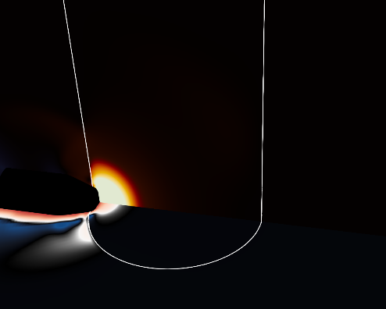  (a) 37 μs | 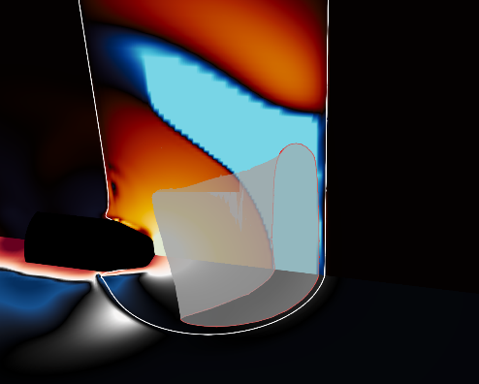  (b) 56 μs | 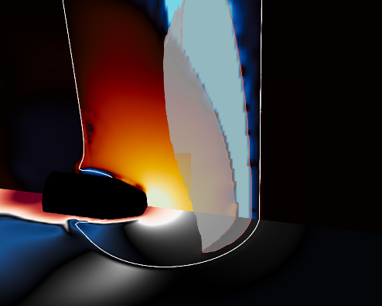  (c) 74 μs
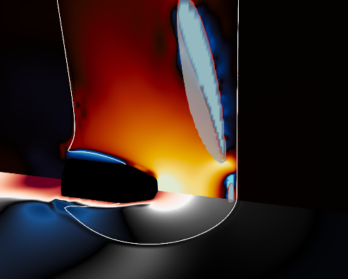  (d) 112 μs | 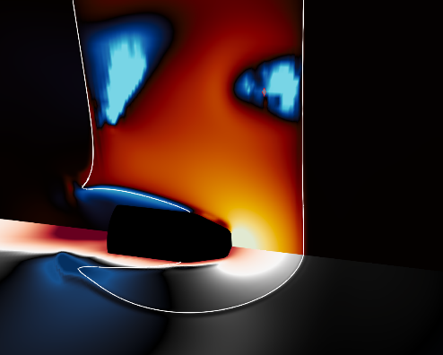  (e) 131 μs | 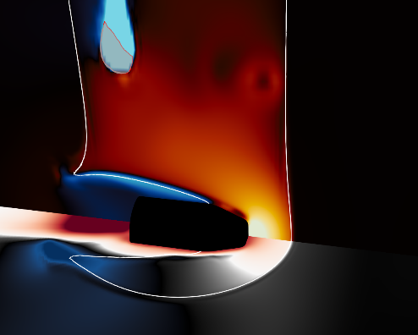  (f) 150 μs
Figure 1 Projectile impact on water jet. Pressure (vertical plane) and longitudinal velocity component (horizontal plane) contours on different time steps. In addition, 0.1% of vapour volume fraction represented by iso-surface and red contour line on planes, and 50% gas volume fraction in white contour line to represent liquid-mixture/gas interface.

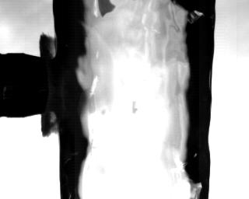  (a) Exp. 37μs | 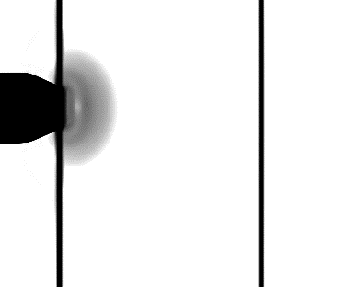  (b) CFD vertical 37μs | 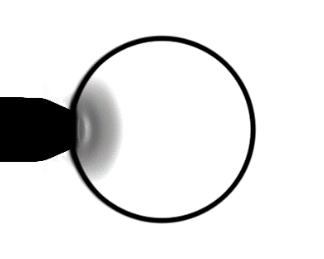  © CFD horizontal 37μs
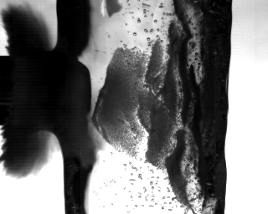  (d) Exp. 56μs | 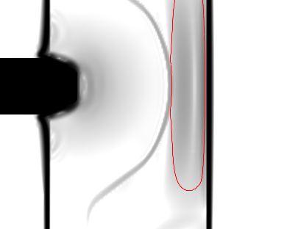  (e) CFD vertical 56μs | 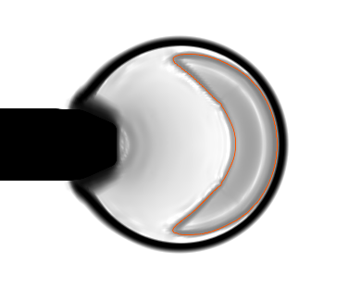  (f) CFD horizontal 56μs
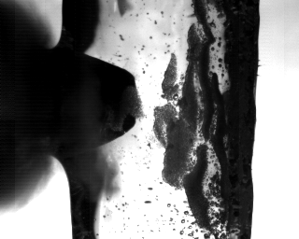  (g) Exp. 74μs | 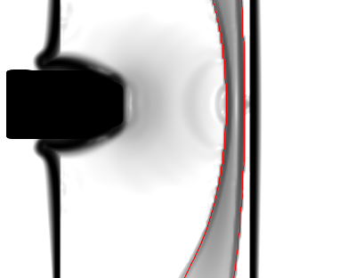  (h) CFD vertical 74μs | 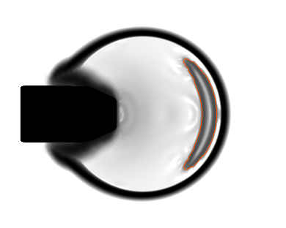  (i) CFD horizontal 74μs
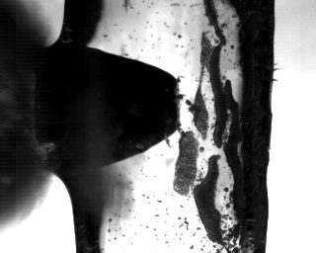  (j) Exp. 93μs | 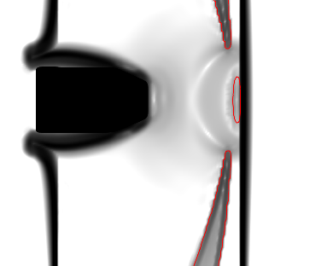  (k) CFD vertical 93μs | 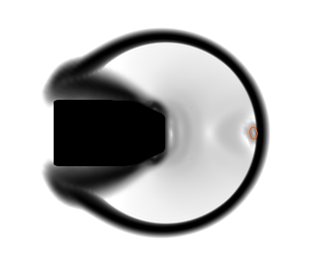  (l) CFD horizontal 93μs
Figure 2 Experimental data from [4] (left) and numerical results (middle, right) for the impact of projectile on water jet, with Uimpact=210m/s. For the CFD results, the logarithm of the magnitude of the gradient of density is plotted on the vertical (middle) and horizontal (right) middle plane on grayscale, along with the 0.1% contour for vapour volume fraction, represented by a red line.

Conclusion
The current study examines the solid projectile impact on a water jet and assess the use of direct forcing Immersed Boundary Method in conjunction with an explicit density based compressible two-phase solver that accounts for cavitation. The physics of the case studied was accurately captured and the simulation results are in qualitative agreement with experiments presented by Field et al. [4]. Pressure shock waves, relief waves and cavitation induction, are present and numerically calculated. A more detailed description of the vapour cavity is provided that is in accordance with the analysis of the experimental data. However, liquid splashing and the anticipated pressure peak values where not observed. Although experimental pressure measurements do not exist for the specific problem, theoretical analysis and experimental data on simpler cases indicate that pressure values exceed water hammer pressures. The Immersed Boundary method used proved not good enough to capture such phenomena and shows room for improvement.

References
- Serge Abrate 2016). Soft impacts on aerospace structures. Progress in Aerospace Sciences, 81(Supplement C):1–17, Dynamic Loading Aspects of Composite Materials.
- F. P. Bowden and J. H. Brunton (1961). The Deformation of Solids by Liquid Impact at Supersonic Speeds. Proceedings of the Royal Society of London. Series A, Mathematical and Physical Sciences, 263(1315):433–450
- J. E. Field, M. B. Lesser, and J. P. Dear (1985). Studies of Two-Dimensional Liquid-Wedge Impact and Their Relevance to Liquid-Drop Impact Problems. Proceedings of the Royal Society of London. Series A, Mathematical and Physical Sciences, 401(1821):225–249
- J.E. Field, J.-J. Camus, M. Tinguely, D. Obreschkow, and M. Farhat (2012). Cavitation in impacted drops and jets and the effect on erosion damage thresholds. Wear, 290–291:154–160
- P. Koukouvinis, C. Bruecker, and M. Gavaises (2017). Unveiling the physical mechanism behind pistol shrimp cavitation. Scientific Reports, (1). Licensed under a Creative Commons Attribution 4.0 International License.
- N. Kyriazis, P. Koukouvinis, and M. Gavaises. Modelling cavitation during droplet impact on solid surfaces. Computer Methods in Applied Mechanics and Engineering. Under Review.
- M. B. Lesser (1981). Analytic solutions of liquid-drop impact problems. Proceedings of the Royal Society of London. Series A, Mathematical and Physical Sciences, 377(1770):289–308.
- Rajat Mittal and Gianluca Iaccarino (2005). Immersed Boundary Methods. Annual Review of Fluid Mechanics, 37(1):239–261.
- Loïc Mochel, Pierre-Élie Weiss, and Sébastien Deck (2014). Zonal Immersed Boundary Conditions: Application to a High-Reynolds-Number Afterbody Flow. AIAA Journal, 52(12):2782–2794.
- Felix Örley, Vito Pasquariello, Stefan Hickel, and Nikolaus A. Adams (2015). Cut-element based immersed boundary method for moving geometries in compressible liquid flows with cavitation. J. Comput. Physics, 283:1–22.
- Charles S Peskin (1977). Numerical analysis of blood flow in the heart. Journal of Computational Physics, 25(3):220–252.

